# EC2 Savings Plan

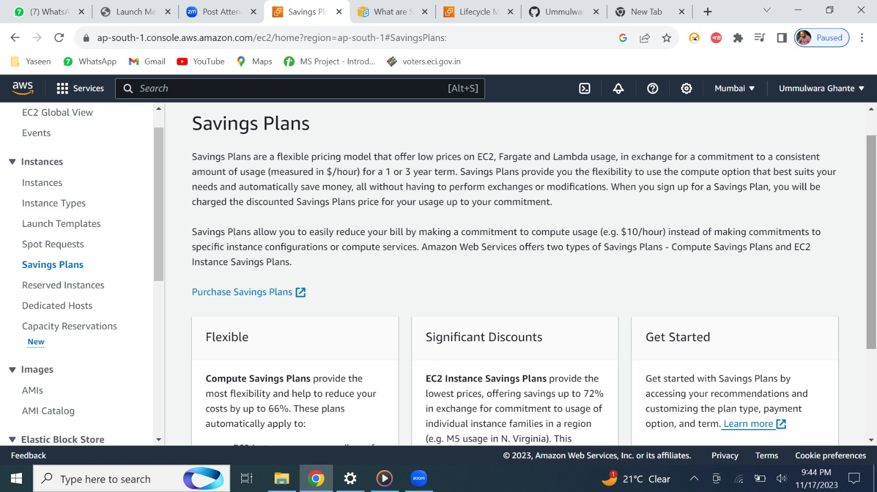



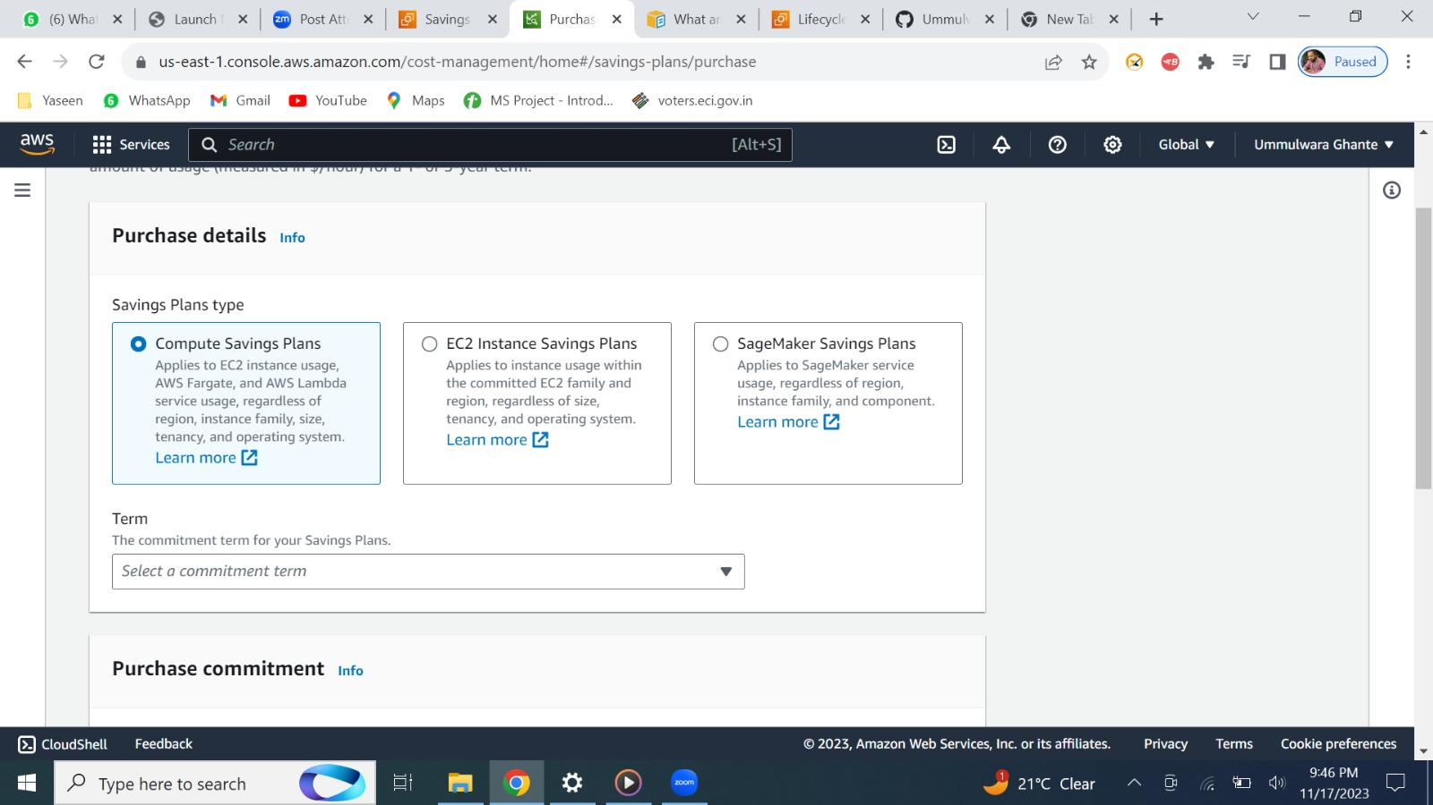



1. **COMPUTE**

In terms we have 1/3 years

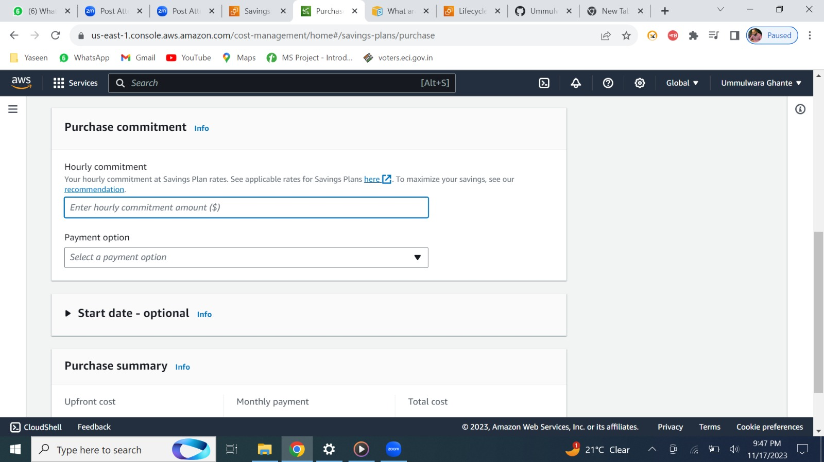



Hourly you can set your price ex: 10$ if it extends more than 10$ then you need to pay extra amount as on demand charge

Payment can be done in 3 options.(upfront ,partial upfront, no upfront)

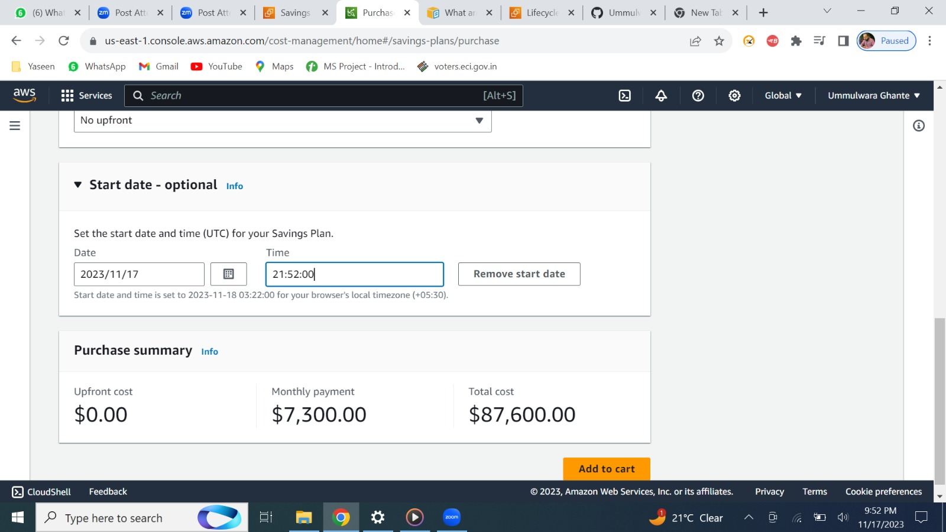



We can set future date and time as when we need to end this particular saving plan, lastly, we can get all total amount.

1. **EC2 INSTANCE**

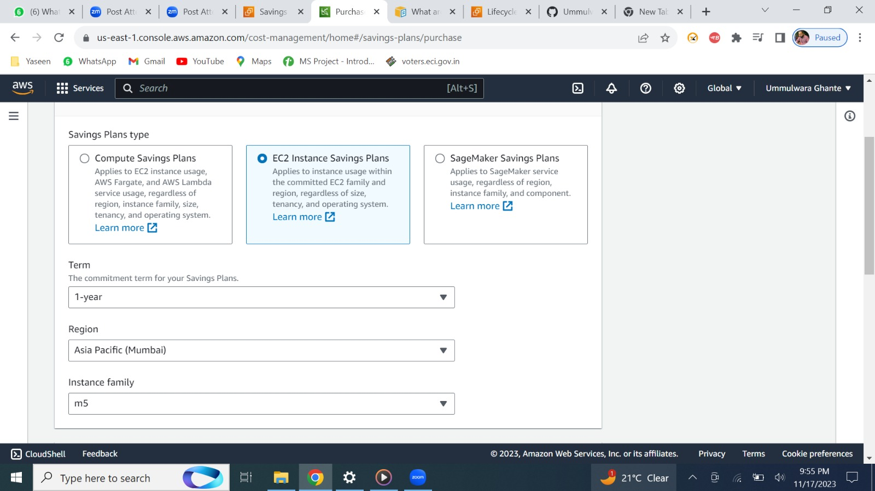



Here we can set the term, region, instance family as it is specific.

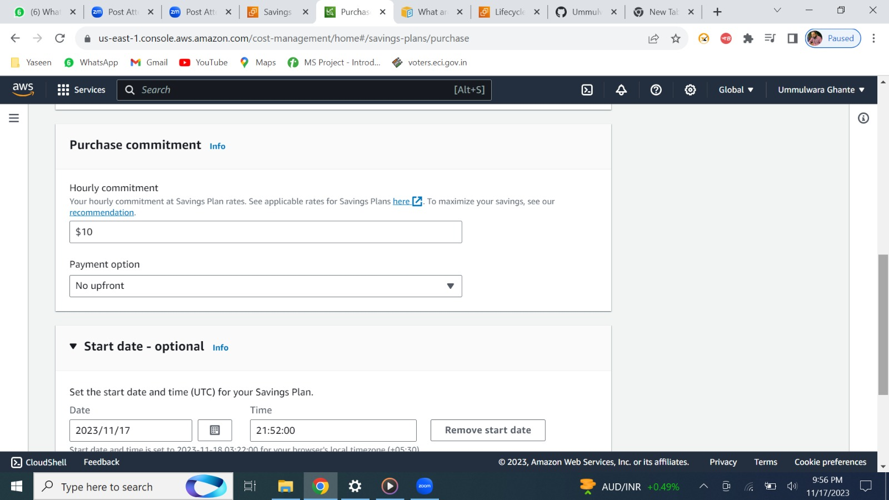



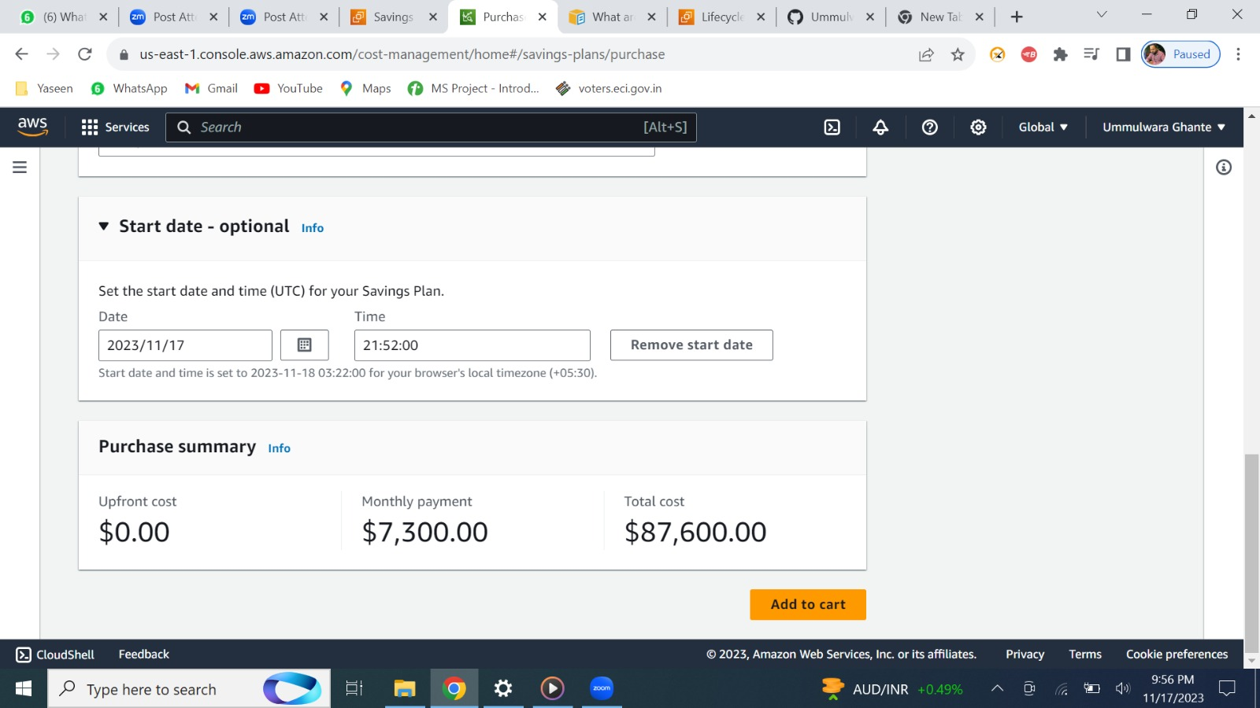



Rest all is same

1. **SAGE MAKER**

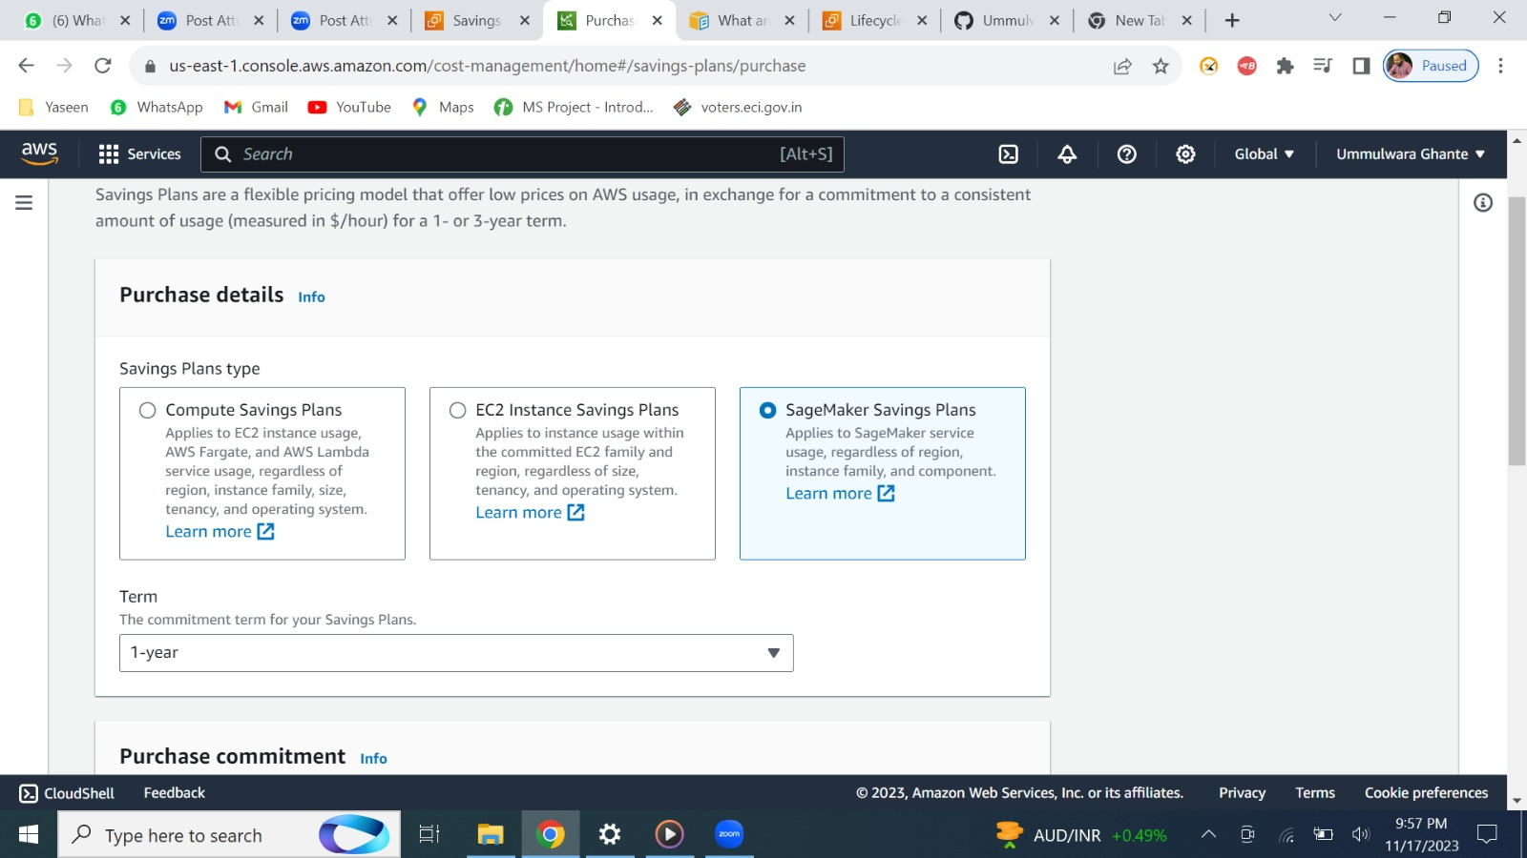



We can have 1yr or 3yr’s commitment.

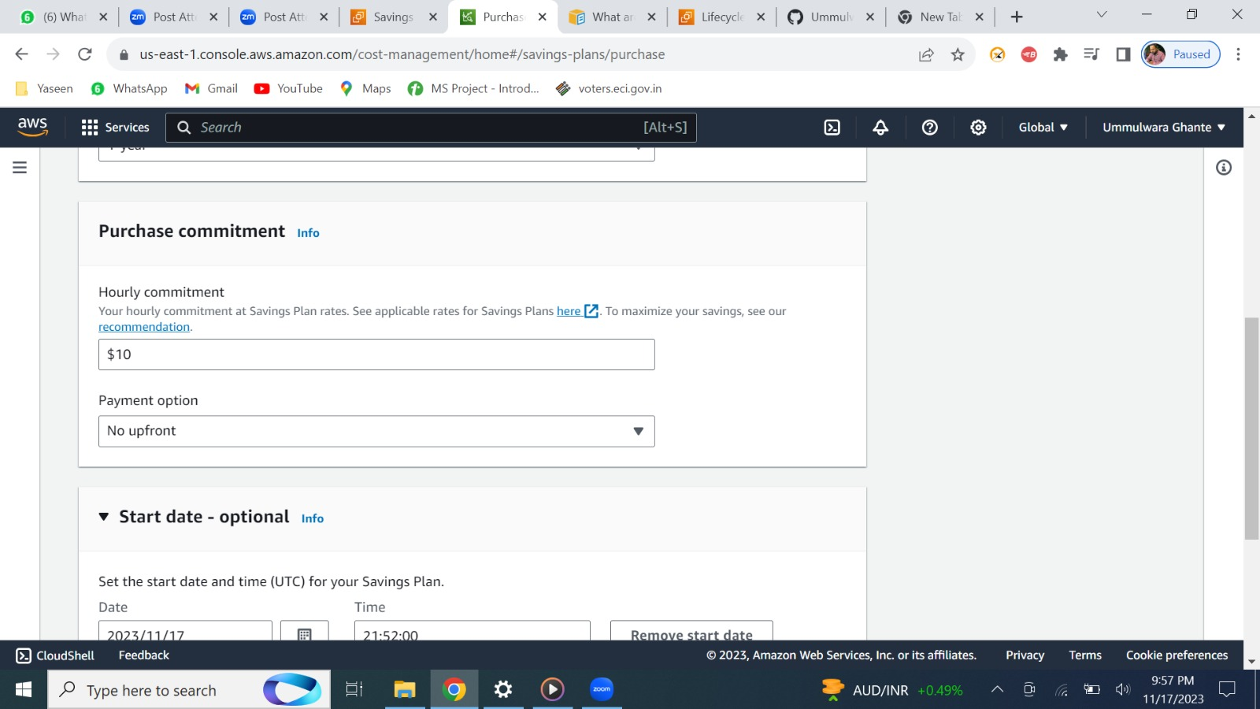



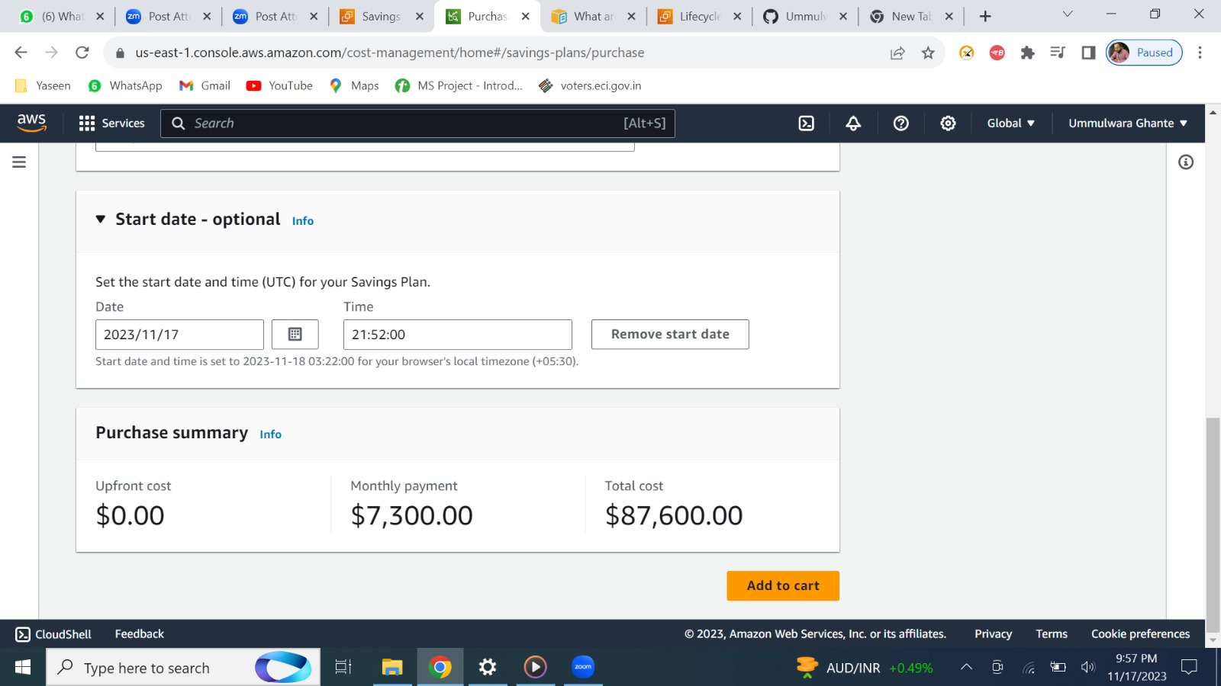



Rest all is same.

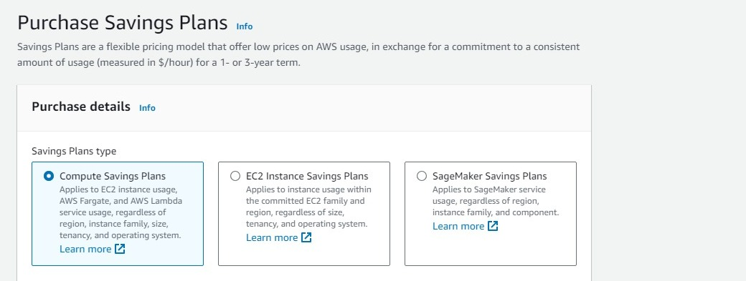

By clicking on learn more you can dive into more about plans.

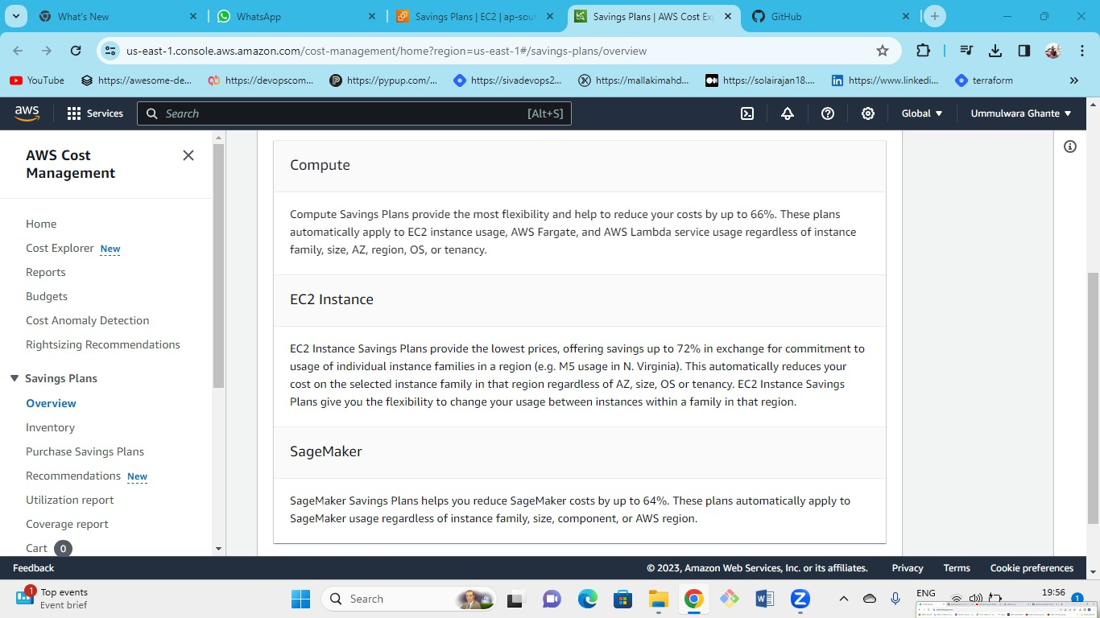

Info about all Saving Plans.